# Acknowledgments

I would like to thank my advisor Profª Emilia Vilani and co-advisor Dr. Edmar Thomaz da Silva for their guidance and trust throughout this project.

To thank my parents, for all of the support that was given to me all of these years and that I will always be thankful for having.

To thank Sidney, that guided me in this universe of blind and visually impaired users. Without him, the devices and the results would be very different, and probably less efficient, than the final ones.

To thank Gabriel ”Boi”, Santiago, André, Wellington and every one of the Competence Center in Manufacturing (and all my other friends that I couldn’t mention here) that shared experiences and knowledge of the daily life of a master’s student and also helped me some of the solutions used in the work.

To thank all of the participants that gave a little bit of their time and patience to provide me with data for this work.

*”As a blind man has no idea of colors, so have we no idea of the manner by which they feel the world.”*

— Isaac Newton (adapted).

# Abstract

The society has reached technology to create autonomous vehicles and to connect different devices and machinery to each other in order to exchange data and to optimize production efficiency. With this technology, soon it will be possible to achieve better methods to guide blind and visually impaired (BVI) users in their daily activities. The products currently available in the market have a number of limitations and do not satisfy BVI users. We believe that one of the reasons behind this problem is that BVI are not members of the development team or are not consulted by these.

The lack of an efficient solution for BVI users navigation became even larger with the SARS-CoV2 pandemic, in which people had to avoid contact with each other and not touch other surfaces.

The purpose of this paper is to use Virtual Reality (VR) to test and evaluate different design of BVI products and to verify if non-BVI users have the same mental demand and situation awareness as a BVI user when using assistive products. The idea is to use the VR as a testing ground where a BVI user can try different assistive solutions in different scenarios. By doing so, the user becomes part of the product design and evaluation, resulting in better and more user-friendly products. The proposed method includes not only the setup of the virtual environment but also the use of physiological sensors and subjective tests in order to assess the mental workload and situational awareness in different situations and/or using different versions of product under development.

To illustrate the proposed method, we use as case study the BVI navigation in a medical clinic submitted to COVID-19 protocols. This case study is chosen due to the current undergoing SARS-CoV-2 pandemic and the impact for BVI people.

The scene was made using Unity3D, a widely used development platform for virtual reality applications. The VR device was the Tobii Eye Tracking VR, a head-mounted display for virtual reality developed using the HTC VIVE. The VR device is used for defining the position and orientation of the user in a virtual environment in Unity. Based on the current situation in the virtual environment, inputs are provided to the user using aural commands and haptics devices. In order to assess the mental workload, physiological sensors, from TEA Captiv T-Sens, are used. Among them, are an electrocardiogram sensor (ECG), to gather heart-rate and heart-rate variance data using, and a galvanic skin reaction sensor (GSR) to collect skin conductance. Beside these sensors, the users are also expected to answer NASA-TLX mental workload assessment test and situation awareness questionnaires.

Among the expected benefits of the proposed method is the flexibility and agility to create different scenarios, as well as the possibility to test all of them in the same physical room. This could not only speed the design of new solutions but also improve the overall quality of the products and to verify the need of a BVI user in the development team of a assistive product.

# 1 Introduction

## 1.1 Motivation

According to the World Health Organisation (WHO), there are at least 2.2 bilions of people with some visual impairment degree (WORLD HEALTH ORGANIZATION AND OTHERS, 2019), hence there is a demand for assistive products in the world. This demand is driven on the unsatisfaction for the current products, since they are not practical, nor portable, invasive or demandful to learn (LOZANO *et al.*, 2009).

This difficulty to use or to learn could be avoided if concepts from human factors, or ergonomics, were analysed during the product’s development, and these could be done using the proper methods. The early application of these methods and tests could be a game changer for the success of the product’s user experience (WOLF *et al.*, 2019).

Another tool that helps training and user efficiency is the Virtual Reality (VR). VR can be used to create specific, immersive and interactive situations that could help the user to learn and train (FARRELL, 2018) and the developers to create more efficient products.

Another strategy to improve the user experience is to bring the user closer to the development team *Adicionar mais coisa*.

As for beginning of February, 2022, about 400 million people had been diagnosed with COVID-19 around the world (RITCHIE *et al.*, 2020). Purposing to try to slow the rate in which the virus spread, WHO recommended strategies like wearing face masks, washing hands regularly, social distancing, avoiding touching surfaces and staying at home

(WORLD HEALTH ORGANIZATION, 2020).

Besides not having a desirable or easily adaptable guidance method, now BVI users’ must avoid touching surfaces, an action that they depend in order to perceive the environment, and keep distance from other people, a task that, besides being difficult to maintain, a BVI user is not used to since he/she depends on others to do their daily activities, like to cross the street (JONDANI, 2021).

## 1.2 Objectives

The objectives of this master’s thesis are to assess BVI users’ using different guidance methods inside a Virtual Environment (VE) and to verify if non-BVI users have the same mental demand and situation awareness as BVI users when using assistive products as in order to improve the development of new assistive solutions for BVI users.

To reach this goal, the following questions must be answered:

1. Do BVI users feel present in the VE as if they were in the real world?
2. BVI users rely on audio cues and haptic feedback to guide. But does it rely more on a type of information than the other?
3. Do non BVI users have the same demands and skill as BVI users when designing assistive products?

## 1.3 Resources and methods

In order to answer all the questions and reach the goal mentioned above, the following resources were allocated:

• To answer about the feeling of presence from BVI users in VE:

* HTC VIVE VR Head Mounted Device (HMD), as show in Figure 1.1;
* A guidance method evaluation questionnaires (See Appendix A.4) . • To answer if BVI rely more in one type of information than the other and if non BVI can undergo the same situations as BVI users when using assistive products:
* Mental workload assessment, using:

∗ Physiological sensors (INSERIR FOTO); ∗ NASA-TLX questionnaire (See Appendix A.2).

* Situation awareness assessment, using:

∗ SAGAT questionnaire (Adapted for this experiment. See Appendix A.3).

## 1.4 Research boundaries

This experiment is not testing the usability of the guidance tools developed for it. This tools are only used here to help users and researchers compare the different feelings provoked by the information transmitted by it.

25

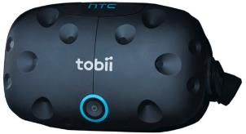

FIGURE 1.1 – VIVE HTC TOBII Virtual Reality Headset.

## 1.5 Structure

This master’s thesis is organized in 8 different chapters and they the following:

• Introduction

It’s the current chapter of this master’s thesis

### • Theoretical Foundation

This chapter explores the mains concepts that are needed to fully understand this experiment. These concepts are:

* Human Factor or Ergonomics;
* Mental Workload (MWL);
* Task Performance;
* Physiological measures; – Subjective measures.
* Situation Awareness (SA);
* Extended Reality (XR);
* Virtual Reality (VR); – Co-Design.

### • Literature review

During this chapter, related articles, i.e articles that involve applications of:

* VR;
* BVI users;
* Human factors.

All these article have some relevance to the current experiment.

*Draft Version: May 31, 2022*

### • Proposal description

Within this chapter, the method will be explained used to reach the goals presented above.

### • Virtual environment development

This chapter is dedicated to explained the steps that was taken in order to design the scene used during the experiment

• Haptic belt development

In this chapter, the process of coding and assembly of the haptic belt is explained.

### • Results’ analysis and discussion

One of the mains chapters of this work. Here is presented and discussed all the gathered results and data

• Conclusion

Finally, which goals were reached and which were not and why they were not.

# 2 Theoretical Foundation

This work use concepts from Human Factors and Co-design and is supported by tools such as Extended Reality (XR), more precisely VR, and some specific assessment methods using task performance, physiological measures and subjective measures. This chapter introduces the need-to-know of each of these to help to better understand this Master’s thesis. Each subject is introduced in the following 5 sections

## 2.1 Human Factor or Ergonomics

Studies started at the Second World War because of the perfomance shortfalls and failures noted in manned equipment. These studies showed that these problems could diminish when Engineering, Psychology and Physiology were gathered when designing a system that was to be handled by a human being (SANDOM; HARVEY, 2004).

This area of study was named ”Human Factors” in United States an ”Ergonomics” in Europe. Despite this difference in the names, today they are considered the same field of study. The International Ergonomics Association (IEA) defines Human Factors, and Ergonomics, as the following:

Ergonomics (or human factors) is the scientific discipline concerned with the understanding of interactions among humans and other elements of a system, and the profession that applies theory, principles, data and methods to design in order to optimize human well-being and overall system performance. Human Factors professionals contribute to the design and evaluation of tasks, jobs, products, environments and systems in order to make them compatible with the needs, abilities and limitations of people (KARWOWSKI, 2012).

Besides being synonyms, this definition shows that humans is a variable inside a system and their interactions should be studied and that is the focus of Human Factors (SANDOM; HARVEY, 2004; SANDERS; MCCORMICK, 1998; DUL; WEERDMEESTER,

2003).

Humans handle with devices, machines and equipment during their daily activities and all of these manipulations are susceptible to accidents or failures that can happen because of the interaction between operator, equipment and environment. Each interface with the operator can be a factor, for example:

* The operator’s body position during an activity;

The position can impact on the comfort felled by the operator and this impacts on its concentration throughout the activity therefore impact on the success rate or in the chance of some accident happen (SANDERS; MCCORMICK, 1998).

* The environment’s lighting;

The illumination can make details easier to be noted without provoking discomfort or distraction to the user and even increase productivity (SANDERS; MCCORMICK, 1998).

* The information displayed and manipulation of the device.

The way an information is displayed on a screen, figure or text impact on how efficient it will be understand by the operator. If this take too long it can draw the operator attention for too long and compromise his/her reaction time.

To take human into account when designing a product or a system is one of the principles for human factors (SANDOM; HARVEY, 2004) and the results of this humancentred-design is already a ISO Standard (BS EN ISO 13407 ‘Human-centred design processes for interactive systems’). This standard was originally written for computerbased-system, but easy applicable in other scenarios and areas (SANDOM; HARVEY,

2004).

It is important to say that when it is said ”User”, it doesn’t mean that one need to design a product specifically for an individual. The design has to be suited to everyone (DUL; WEERDMEESTER, 2003).

”Human-Machine systems” (on this thesis, for now on, called simply ”Systems”), are interactions between humans and machines. These systems are designed to have an input, or demand, and an output, or product. Here, ”machine” can be any manipulated object, from a simple screwdriver until a car, or some machine operated by more than one human, like a cargo ship for example. The Figure 2.1 represent a general human-system machine interaction.



Information

processing



Controlling



Controls



Operation



Display



Senses

Human

Machine

WorkEnvironment

Input

Output

FIGURE 2.1 – Human-Machine system representation (SANDERS; MCCORMICK, 1998).

## 2.2 Mental Workload (MWL)

Mental workload (MWL) is one of the main concepts studied in Human Factors and is not a familiar concept to the most people (STANTON *et al.*, 2004). A good way to explain it is with a analogy with physical workload (STANTON *et al.*, 2004). When a athlete must lift a dumbbell (one of those gym’s weights bars). The strength’s demand from the athlete will be proportional with the the dumbbell’s mass he/she is lifting. If the dumbbell is lighter than the athlete’s capability, then it will be easy enough for him/her to lift it. So if the athlete is strong enough to carry the dumbbell, he/she will not feel a physical demand bigger than his/her capabilities. So the physical workload of this activity is properly fitted for this athlete.

If the dumbbell is heavier than the athlete can lift then two things can happen:

* Or the athlete adapts to lift that dumbbell using tools (adjust the strategy)
* Or the athlete will not be able lift completely the dumbbell (performance degrades)

This is a scenario that represent an user, or operator, executing a task that is not fitted for their capabilities.

It is the same with MWL. Each human being has a finite mental capacity and can only use it with a limited number of tasks at the same time. If the sum of these mental demands are higher than the user’s capacity, the user will need to adapt in order to finish those task, otherwise he/she will compromise the overall performance of those tasks.

Although, if the workload is too low, the same operator may get bored and easily distracted and so could also fail or not process the task’s information.

It’s important to say that MWL is unique within each individual and is influenced by his/her perception of the task‘s workspace but is also impacted by other factors outside the task itself and more related to the operator (like it’s skill, age, education, training) or to the environment (like noise, heat and toxicity) (CAIN, 2007; FALLAHI *et al.*, 2016; CARDOSO; GONTIJO, 2012).

MWL is not a quantitative resource or something that one can directly measure, but is has methods to infer it. The Figure 2.2 has an overview of MWL and its measureament methods.

### 2.2.1 Task Performance

If the MWL influences on the task perfomance, then it would be possible to infer it using the performance’s variation of a task. Because there are cases that the user’s mental capacity is too high for only one task, two tasks are designed. In these evaluations, the user is asked to maintain a good perfomance level and still try to execute both tasks. Both tasks are similar and use the same kind of skill. (STANTON *et al.*, 2004; SANDERS; MCCORMICK, 1998).

For example, an experiment to assess MWL in a flight simulator that uses two tasks:

* Fly a fighter aircraft and maintain a good performance level;
* Mentally sum two random numbers that appear on the screen. If the numbers’ sum is odd, then the pilot should press left on the keyboard, if the result is even the he/she should press right.

If the pilot’s performance at the second task is too low, it means that the demand from the first task is too high for him/her to be able to pay attention on it, than it means that the MWL at the flight was high (MOHANAVELU *et al.*, 2020).



Mental



Task

Demand



Mental

Capacity

workload



Primaryand



Physiological



Subjective

secondary tasks measurements measurements

FIGURE 2.2 – A overview of mental workload and the methods to infer it.

### 2.2.2 Physiological measures

There are many physiological reflexes that one can use to assess MWL. These measures are a good, unbiased method to assess MWL (FALLAHI *et al.*, 2016), but, still, it is recommended that they are evaluated alongside other method. It is possible to extract MWL information from the heart and brain activity (CHAKLADAR *et al.*, 2020; ORLANDI; BROOKS, 2018), skin conductance, eye movement, pupillary contraction (STANTON *et al.*, 2004; RODR´IGUEZ *et al.*, 2015) This master’s thesis it is used heart activity and skin conductance.

2.2.2.1 Heart rate and heart variability with electrocardiogram (ECG)

Electrocardiogram is a recording of the heart’s electrical activity. With this recording one can verify the heart’s interval between heartbeats and frequency (heart rate, HR), and other statistical parameters such as the standard deviation and the mean error (heart rate variability, HRV) and these are a good way to assess MWL (CAIN, 2007). This is a simple and non-invasive method used in many human factors’ experiments (MOHANAVELU *et al.*, 2020; MANSIKKA *et al.*, 2016; ZHANG *et al.*, 2014).

The heart activity is controlled by the sympathetic and parasympathetic nervous systems. These systems are responsible to control many of the body’s autonomous activities (STANTON *et al.*, 2004). (DEFINIR MELHOR)

During a task that has a mental demand the user’s heart activity changes with MWL. The higher the MWL, higher the HR and lower the HRV. This happens because of the mechanism that controls our heart activity. These are consequences of two reactions in our system when in a mental demand situation (STANTON *et al.*, 2004).:

* A decreased parasympathetic nervous system activity and;
* An increase sympathetic nervous system activity.

2.2.2.2 Electrodermal response with galvanic skin reaction (GSR)

One of the electrodermal activity that can happen in our skin is controlled by the the sweating and the moisture level and both can be used to reveal changes in our sympathetic system (NOURBAKHSH *et al.*, 2012; SHI *et al.*, 2007). So its origin lies solely in the sympathetic branch of the autonomic nervous system as is MWL (STANTON *et al.*, 2004). EDA is being used to assess stress, emotion, arousal, mental strain and cognitive activity (NOURBAKHSH *et al.*, 2012; STANTON *et al.*, 2004; SHI *et al.*, 2007)m also used to evaluate the usability of HCI systems (SHI *et al.*, 2007) and some are to assess the mental workload (ZHANG *et al.*, 2014; BORGHINI *et al.*, 2014).

### 2.2.3 Subjective measures

It is discussed if one should only use subjective measures to measure MWL (SANDERS; MCCORMICK, 1998; STANTON *et al.*, 2004). They are sensitive to perceived difficulty, automation, concurrent activities and demand for multiple resources. These test can be unidimensional, that are simplier but has only a general workload score (STANTON *et al.*, 2004), or multidimensional. Some example of the latter is the Subjective Workload Assessment Technique (SWAT) and the NASA Task Load Index (NASA-TLX), both multidimensional tests. SWAT treats MWL as a load defined by three dimensions: time load; mental effort load; and psychological stress. In this test the user score each of these dimensions based on a 3-point scale while NASA-TLX uses 6 different dimensions.

2.2.3.1 NASA-TLX

NASA-TLX is a questionnaire created by Hart e Staveland (1988). It is answered by an user who has just completed a task/activity that someone wish to infer its MWL. This questionnaire will assess the task’s MWL felt by that user with 6 rating scales and each of these is explained, ideally, at the experiment’s briefing. The Table 2.1 presents each scale with a description of it.

TABLE 2.1 – NASA-TLX dimensions and the description of each dimension. (STANTON *et al.*, 2004).

|  |  |
| --- | --- |
| Dimension | Explanation |
| Mental demand (MD) | The mental and perceptive activity demanded by the task (chose, decide, think, calculate, search, etc.). |
| Physical demand (PD) | The physical activity demanded by the task (pull, lift, spin, drag, etc.). |
| Temporal demand (TD) | The time pressure felt by the user. A rating the leverages the time available and the time necessary to completed the task. |
| Performance (PE) | The user’s satisfaction with it’s perfomance or result the task. |
| Effort (EF) | A rating of the effort necessary to achieve that perfomance felt by the user. |
| Frustration (FR) | A rating of stress, annoy or irritation felt by the user throughout the task. |

This questionnaires evaluate only one task/activity. So if the user executed two tasks (like a primary and secondary tasks), he/she should be oriented to answer about primary task only, not a combination of both of them (SANDERS; MCCORMICK, 1998).

To measure mental workload, it is recommended not to chose only one measuring method, but more. MWL is multidimensional and can reflect partially or differently in each of the methods (SANDERS; MCCORMICK, 1998).

## 2.3 Situation Awareness (SA)

Situation awareness (SA) can be defined as ”the perception of the elements within a volume of time and space (Level 1), the comprehension of their meaning (Level 2), and the projection of their status in the near future (Level 3)”. The term was first written in the aeronautic sector. Today is key factor when designing complex and dynamic system’s, i.e the aeronautic and automotive, medical and nuclear power plants systems (ENDSLEY, 1995). It is an important factor to make sure that the user will be capable to take important decisions correctly and achieve high performance (ENDSLEY, 1988a; ENDSLEY, 2018).

For example, when an air traffic controller looks at a radar display, he/she seeks to understand the aircraft’s position and speed and then predict their position in the near future (5, 10 or 15 minutes after) (SANDERS; MCCORMICK, 1998), or when a pilot reads the cockpit panel, understands their data then he/she is able to predict the next reading of that same instrument or some other status of the aircraft after a couple of minutes.

As is with MWL, SA is not a quantitative subject. The most common way to to measure SA is by subjective methods, like for example the Situation Awareness Rating Technique, but is not reliable since it can distort the participant’s answer (STANTON *et al.*, 2004), and the Situation Awareness Global Assessment Technique (SAGAT). The Figure 2.3 represents an overview of SA.



Information



1

stLevel

Perception



2

ndLevel

Comprehension



3

rdLevel

Projection



Decision

making

FIGURE 2.3 – A overview of situation awareness and the SAGAT.

### 2.3.1 SAGAT

The Situation Awareness Global Assessment Technique is a method developed by ENDSLEY in 1988b. It is based on how the information is processed inside the user’s mind. The test application is made by stopping the operator activity, usually made in a simulation, then asking the user an amount of questions that were previously created based on the user’s activity. These questions should be as similar as possible to how the person thinks when thinking about that information in order to avoid extra effort in understanding it (STANTON *et al.*, 2004).

Although the stopping during the activity may sound troublesome for the testing, empirical work shown that that doesn’t interfere with the the user performance and the user memory can withstand a break as long as 5 to 6 min ENDSLEY

## 2.4 Extended Reality (XR)

Extended reality refers to the interaction of a Human-Machine system with a real and virtual interface together. It has four differents forms:

* Augmented Reality;
* Augmented Virtuality;
* Mixed Reality;
* Virtual Reality.

These forms differs from one another based on a leverage of reality and virtuality involved on the system. To help to visualise these differences, Milgram e Kishino (1994) created the concept of ”virtuality continuum” and is presented on Figure 2.4.



Real

Environment

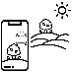

Augmented

Reality



Augmented

Virtuality



Virtual

Reality

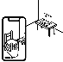

Mixed

Reality

FIGURE 2.4 – The Virtuality Continuum concept (MILGRAM; KISHINO, 1994)

The extreme left means full reality, where the stimuli does not come, or is not produced, from any computer or any other digital system. Along the path to the right, the environment starts to have some digital elements until it reaches the far right, where all the elements in the environment have a digital origin (NIJHOLT; TRAUM, 2005; DOOLANI *et al.*, 2020). The first step from the Real Environment towards Virtual Reality is the Augmented Reality.

### 2.4.1 Augmented Reality (AR)

In augmented reality, the user can see some digital elements, that could be text, images, video, etc, that are laid in a real environment without the user losing the sense of presence in the real world. Some uses for AR are to assist workers in the manufacturing, assembly tasks and in training (DOOLANI *et al.*, 2020; FARRELL, 2018; MA; CHOI, 2007).

### 2.4.2 Augmented Virtuality (AV)

While AR brings digital elements inside a real environment, Augmented Virtuality creates an environment that could only exist with a digital origin, like a fantasy world from games or movies. This scenario is the background of some other activity that is being done in a real environment. An example could be using a virtual environment during the a pilot or driver training or an engineer visualizing a real-time model of an aircraft in flight (FARSHID *et al.*, 2018). Other example could be playing sports the use an equipment to play it, like tennis, golf or baseball but the arena is completely digital. The user can use the real equipment with a tracker, but, besides that, the rest would be all digital.

### 2.4.3 Mixed Reality (MR)

Mixed Reality stay in between Real and Virtual Environment. But what is the difference between MR and AR or AV? In MR the user can manipulated the digital element, as if it where inside the real world (DOOLANI *et al.*, 2020). For example, a client from a furniture store could use MR to see what product fit inside his/her room. He/she can move the furniture inside the room and see if the colors, size and shape fit before buying or even going to the shop.

### 2.4.4 Virtual Reality (VR)

Resting in the far right of the virtuality continuum, the Virtual Reality has its user as the only element that hasn’t a digital origin, making he/she totally immersed in a virtual environment, but, of course, inside the physical limits of a real environment (MA; CHOI, 2007). If the feeling of presence of that environment is well done, the user can momentarily forget about the real environment and act and react accordingly to the virtual environment (FARRELL, 2018).

VR is a powerful tool that allow an user to be transported to a tridimensional environment that could be out of reach or that doesn’t exist but is perfect to test or train some situation. Inside this virtual environment the user can walk and look around and interact with the many elements as if they were real (MUJBER *et al.*, 2004) and this technique becomes more effective and valuable when one can simulate a real situation and use it for training (SALAH *et al.*, 2019).

The Figure 2.5 shows the representations of each of these Extended Reality subsections.

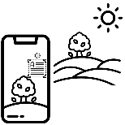

Augmented

Reality

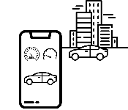

Augmented

Virtuality

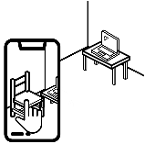

Mixed

Reality



Virtual

Reality

FIGURE 2.5 – A represantion of the differences between AR, AV, MR and VR

## 2.5 Co-Design

Collaborative design is a way to design that each element inside the design team has a different experience, resourcers, ideas or formation that is important for the product effectiveness. It is based on a good communication and in the information sharing (CHIU, 2002). Still, it is common to say ”collaboration” interchangibly with ”interaction” and ”cooperation”. Some authors define those words differently. ”Interaction”is a more formal relationship between the elements (KAHN, 1996) and ”cooperation” focus more on the coordination and the mutual gain or benefit between the elements (SMITH *et al.*, 1996).

For collaborations, the shared vision and the process to be followed are imporant (KLEINSMANN, 2006).

Collaborative design is the process in which actors from different disciplines share their knowledge about both the design process and the design content. They do that in order to create shared understanding on both aspects, to be able to integrate and explore their knowledge and to achieve the larger common objective: the new product to be designed (KLEINSMANN, 2006).

According to Kleinsmann (2006) there are two aspects that are important for Collaborative Design:

Information is a data after the receiver understanding, or translating, process. Knowledge is the data in a state that is possible record, register to remember later inside the individual’s memory. This can be ideas, facts or concepts. During the collaborative design, these ideas, facts or concepts are exchanged between the actors. This exchange is a fundamental part of this method since it is responsible for the growth of each individuals’s knowledge and this is used to perform their individual tasks. This brings us to the second aspect, the knowledge integration (KLEINSMANN, 2006).

With both of these aspects in mind, Kleinsmann (2006) defines Collaborative design as ”the process in which actors from different disciplines share their knowledge about both the design process and the design content”. This happens to increase the team understanding to help them to design a new product based on all of their knowledge and experience.

# 3 Literature review

For the literature review of this work the following steps were taken in order to gather the used information.

• Search through the Scopus and Web of Science platforms;

* Search the Scopus plaform:

∗ Filter articles using the keywords ”Human Factors”, ”Virtual Reality”; ∗ Filter articles from 2019 until 2022 and related to engineering or social science;

∗ Read the title and abstract and select the more relevant of them; ∗ Read the selected articles.

* Search the Web of Science:

∗ Filter articles using the keywords ”Human Factors”, ”Virtual Reality”, ”Covid-19” and ”Blindness”;

∗ Read the title and abstract and select the more relevant of them; ∗ Read the selected articles.

After following these steps, 344 abstracts were read and from these the following articles were selected as the most relevant for the research.

## 3.1 Virtual Reality Without Vision

SIU *et al.*, also motivated by the popularization of the VR technology, developed a White Cane to be used by BVI users in virtual environments and to make virtual reality application useful for these users as well. The traditional white cane transmits three sources of information to the user: Detection of obstacles, surface topography and footplacement preview and these information are transmitted through sounds or haptics (SIU *et al.*, 2020) and the developed cane would simulate that in the virtual environment.

For the obstacle detection, the new cane was build with a three degree-of-freedom brake mechanism that would stop the movement when the cane hit an obstacle. It was installed a voice coil actuator that was used to detect surface properties or other information that had a higher frequency than the capacity of the brake mechanism. Lastly, a wave-based acoustic simulation was used to render geometry-aware sound effects in other to enable the user a sense the surroundings using the sounds (Echolocalisation).

The experiment’s participants were meant to play a ”Scavenger Hunt” using a HTC Vive. During the experiment each participant had two tasks:

* Collect targets along the way;

The main task. Five targets appeared, one at a time, once the previous target was collected, and they emitted a sound that acted as an audio beacon for the participant. The experiment was concluded when the participant collected all of them.

* Avoid virtual obstacles and walls.

The secondary task. These obstacles didn’t emit any sound as a beacon, but the participant could detect it by the shape and by the noise it emits when in contact with the cane. All the obstacles had the same geometry and material, a cube shaped metal. When tapped by the cane, this object emitted a metal clinking sound.

Besides the audio beacon and the metal sound, there were also a sound when a target was collected, when colliding with a wall and with an obstacle. Figure 3.1 shows the targets obstacles and the starting point location.

The experiment was performed with 8 blind users (4 female, 4 male) from 25 to 70 years old. All of them did a training section where it was presented to them the mechanics of the virtual environment and how to detect walls, doors and obstacles. Figure 3.2 shows both the training and the game rooms.

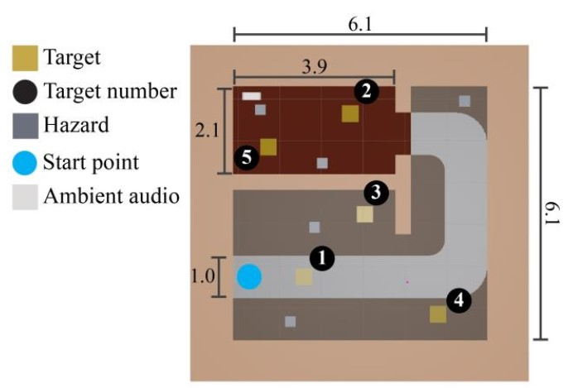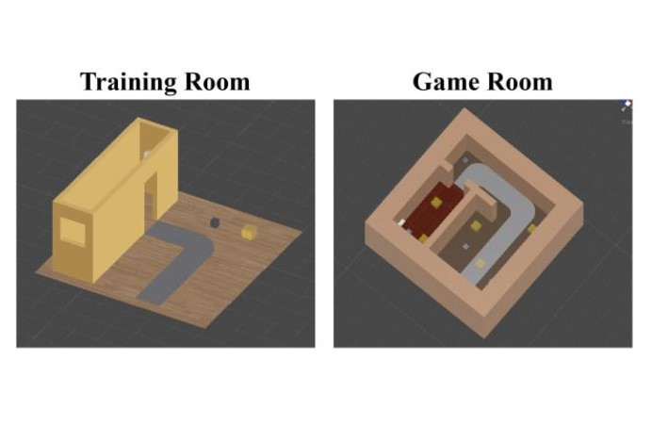

FIGURE 3.1 – Siu et al. key locations. Dis- FIGURE 3.2 – Siu et al. training and game tances are in meters (SIU *et al.*, 2020). rooms layout (SIU *et al.*, 2020).

The researcher found out that the simulated vibration of the cane confused part of the participants, while other part were familiar with that vibration of the cane. This was reflected in the performance of this participants. The ones that were already used with this vibration performed better. This shows that user preferences can impact their perfomance and experience in the VE.

Another point taken by the researcher was about navigating in tight spaces. Is was easier for the participants to navigate in larger areas, similar as it is said in real world.

The final conclusion was about the exploration of the environment. The participants were focused in finding all of the target and did not explore the environment. This might have caused a bias in the low time and low obstacle hits. So it not sure that the tool could help a BVI user to freely explore a VE.

The authors noted some limitation. The cane, even though it had a good brake system, it didn’t stop the participant when he/she walked forwards towards a wall. The lack of variation in the cane material and in the feedback possibilities (i.e when the obstacle contact a point along the cane, not the tip of it).

The present experiment has similar motivations, to study or improve BVI users’ navigation, but in different environments. While the work from SIU *et al.* was focused in the navigation of BVI users inside a VE, this experiment uses VE to assess BVI navigation in a simulated real environment. SIU *et al.* commented the importance of the sound in the guidance of the BVI and used spatialized audio to increase the realism and received a positive feedback by the participants as this experiment also did.

One big difference between the two works is the cane. SIU *et al.* used a cane controller that represented a virtual cane inside the VE, as was made in this work with the *Virtual Cane*, but the feedback from the *Virtual Cane* interaction on the VE was only a vibration, whilst the cane controller, besides using a high frequency response that could be said to be similar to a vibration, used a brake system to simulate the contact with the wall or obstacle. This experiment couldn’t apply this resource for financial and time reasons.

## 3.2 Effects of Emotion and Agency on Presence in Virtual Reality

One of the many feelings that flourish during the use of a VR is the feeling of presence. This feeling, inside the virtuality context, is when someone feels draw into a VE and starts to occupy the VE instead of the real one (CUMMINGS; BAILENSON, 2016).

Jicol *et al.* (2021) explores this feeling in its work. The authors aim to correlate the feeling of presence with one’s agency (which is the self perception that the user is in control of a situation or some actions (FARRER; FRITH, 2002)) and emotion, both of these in a VE context. Besides assessing this correlation, the author also did a structural equation model (SEM) based on their findings. The author did this by creating two different VE, one that would trigger happy emotions, and another that would trigger fear. For each VE there was two different variations of it, one that the user could interact with it’s elements and another that it could not. So at the end, four different VE were designed as the Figures 3.3a to 3.4b show.

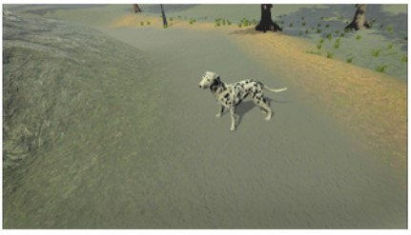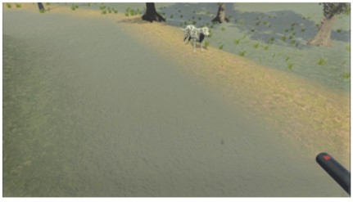

(a) Without agency. (b) With agency.

FIGURE 3.3 – Happy environment (JICOL *et al.*, 2021).

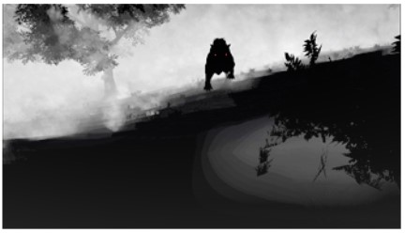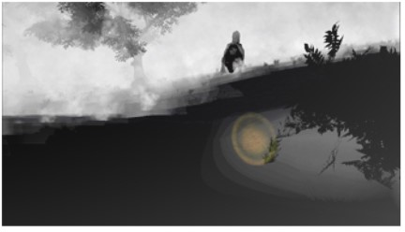

(a) Without agency. (b) With agency.

FIGURE 3.4 – Fear environment (JICOL *et al.*, 2021).

This experiment had 121 participants and they were randomly assigned to one of the four VE. Participants with a neurological disease, fear of dogs, psychological or emotional issues, epilepsy or use of medical device were excluded.

The authors had three hypothesis about their experiment:

1. The intensity of the dominant emotion in each VE will correlate positively with the presence
2. Presence will be significantly higher in environments where participants have agency
3. Agency will moderate the effect of the emotion on the presence

The first hypothesis was confirmed. No matter if the feeling is positive (happiness) or negative (fear), the users did felt a stronger presence when the positive or negative feeling were more intense.

The second hypothesis was partially correct. In the VE that provoked fear, agency did make a difference and induced a higher feeling of presence, whilst in the VE that provoked happiness, agency did not affected the presence. The same could be said about the third hypothesis.

This is an important work for its findings about the user’s presence feeling. Inside a VE, users that have a direct interaction inside it do find a bigger feeling of presence. This is important for this master’s thesis experiment. It is possible that, if the participant did not feel ”present” inside the VE, the gathered data could be less sensitive to the experiment’s goals.

This experiment did not assess directly the feeling of presence, but the feeling of presence inside a VE with BVI users could be a suggestion for future works or even a base study.

## 3.3 Bradley and Dunlop research about BVI navigation

Bradley and Dunlop written two works about BVI navigation, one in 2002 and the last in 2005.

### 3.3.1 The 2002 investigation

On 2002 they studied which information BVI users used throughout their navigation and compared the data collected with another similar data, but instead it was answered by sighted users. This second data was also collected by the same researchers in a prior investigation, made also in 2002, and both of the data were collected using the same interview’s structure.

This investigation was made by analysing the answers from a interview with the participants. In this interview, the participants had to explain how to arrive to two different location as if they were talking to someone with the same condition. The answer were than classified in 11 different categories:

* Directional (e.g. left/right, north/south)
* Structural (e.g. road, monument, church)
* Environmental (e.g. hill, river, tree)
* Textual-structural (e.g. name of shops, places, restaurants)
* Textual-area/street based (e.g. name of street, neighborhoods, squares)
* Numerical (e.g. first, second, 100m)
* Descriptive (e.g. steep, tall)
* Temporal/Distance based (e.g. *”walk until you reach...”* or *”before you get to”*)
* Sensory (e.g. sound of engines, smell of bread from a bakery)
* Motion (e.g. cars passing by, doors opening)
* Social Contact (e.g. asking people or using a guide dog for help)

The motion and the social contact was added in the interview with the BVI users, so the researches re-analysed the sighted answers to fill this classification as well. The Figures 3.5 and 3.6 show their findings.

Average nº of utterances used within each contextual category between sighted and visually impaired participants

0

Type of contextual categories

Averagen

º

ofutterance

5

10

15

20

25

30

35

40

45

50

55

60

65

70

75

80

85

90

Direct

Struct

Environ

Text-struct

Text-area/st

Numer

Desc

Sensory

Tem/Dist

Motion

Social

Visualy I

mpaired

Sighted

FIGURE 3.5 – Comparison between sighted participants with BVI participants (BRADLEY; DUNLOP,

2002).

In conclusion the researches realised that BVI participants use less text-based information than the sighted participants, but BVI participants used more words to describe a path than the sighted participants.

Besides describing the paths to reach the destinations, the researches also asked the BVI participants their ”opinions on the importance of different types of contextual information for route navigation, design issues relating to usability and their mobile needs/requirements”(BRADLEY; DUNLOP, 2002). Many participants said that white canes and guide dogs had limitations and also commented that sensory information are very important when different types were used together in order to confirm one information.

Average nº of contextual categories used per participant

within sighted and visually impaired groups

0

Groupsusedfor

comparison

1

2

3

4

5

6

7

8

9

10

11

Sighted

VisuallyImpaired

Average nº of categories used for each route description

FIGURE 3.6 – Number of categories used by each group (BRADLEY; DUNLOP, 2002).

### 3.3.2 The 2005 experiment

Based on the findings from 2002, Bradley and Dunlop designed an experiment to investigate if there is a difference between the perceived workload of both BVI participant and sighted participants when then navigate using a user-tailored information created with the results of both previous experiments.

16 participants, 8 sighted and 8 BVI, were recruited to walk to four pre-determined landmarks at the centre of Glasgow. They followed the same orientations that were pre-recorded and given to the participants. For each participant, orientations for 2 of these 4 landmarks, that were made using based on the proportions of the results of the sighted users’ interview, were randomly given. Similar was made with the remaining 2 landmarks, but with orientations made with the findings of the BVI users’ interview. These proportions are presented at the Table 3.1

TABLE 3.1 – Proportion of each type of information used by sighted and BVI participants (BRADLEY; DUNLOP, 2005)

|  |  |  |
| --- | --- | --- |
| Class of contextual information | % Used Sighted | % Used BVI |
| 1. Directional | 37.4 | 30.1 |
| 2. Structural | 11.5 | 20.1 |
| 3. Environmental | 1.6 | 2.9 |
| 4. Textual-structural | 9.9 | 1.2 |
| 5. Textual-area/street | 15.6 | 2.7 |
| 6. Numerical | 5.0 | 7.5 |
| 7. Descriptive | 10.8 | 23.8 |
| 8. Temporal/distance | 8.2 | 5.1 |
| 9. Sensory | 0 | 4.4 |
| 10. Motion | 0 | 0.8 |
| 11. Social contact | 0 | 1.4 |

Their results found out that BVI users reached landmarks significantly quicker when given the information that were made for that group, but still longer than sighted users. This comparison is show in the Figure 3.7 and 3.8. Condition 1 is the verbal orientation made for sighted users and condition 2 is the verbal orientation made for BVI users

Comparing condition times for Comparing condition times for visually impaired participants sighted participants

0

Averagetime(secs)

50

100

150

200

250

300

Con1

Con2

0

Averagetime(secs)

50

100

150

200

250

300

Con1

Con2

Lan 1 Lan 2 Lan 3 Lan 4 Lan 1 Lan 2 Lan 3 Lan 4

FIGURE 3.7 – Mean times for each land- FIGURE 3.8 – Mean times for each landmark performed by the sighted participants mark performed by the BVI participants

(BRADLEY; DUNLOP, 2005). (BRADLEY; DUNLOP, 2005).

After the experiment a NASA-TLX was completed by each participant. The score for each dimensions is show in the Figures 3.9 and 3.10. These scores show that BVI participants did had higher workload when guided by the condition 1 as well as the sighted participants did with the condition 2.

Comparing visually impaired

participants’ workload rating for both

conditions

0

Averageweighted

score

50

100

150

200

250

300

350

dition 1

Con

dition 2

Con

Comparing visually impaired

participants’ workload rating for both

conditions

0

Averageweighted

score

20

40

60

80

100

120

140

160

180

Con

dition 1

Con

dition 2

MD PD TD OP EF FR MD PD TD OP EF FR

Type of contextual categories Type of contextual categories

(a) BVI participants. (b) Sighted participants

FIGURE 3.9 – Comparison of the NASA-TLX between the conditions (BRADLEY; DUNLOP, 2005).

Comparing group scores for condition 1

0

Workload dimensions

Averageweightedscore

50

100

150

200

250

300

350

MD

PD

TD

OP

EF

FR

y impaired

Visuall

Sighted

1.

(

a)Condition

Comparing group scores for condition 2

0

Workload dimensions

Averageweightedscore

50

100

150

200

250

300

MD

PD

TD

OP

EF

FR

Visuall

y impaired

Sighted

(

b)Condition

2.

FIGURE 3.10 – Comparison of the NASA-TLX between the participants (BRADLEY; DUNLOP, 2005).

This current experiment used their conclusion in order to create proper navigation commands used in the experiment. Another difference between this experiment and the one written by the duo is the inclusion haptics information in the scope of studied guidance commands.

## 3.4 Evaluation of spatial display for navigation without sight

In the work of (MARSTON *et al.*, 2006), the author wanted to test a prototype developed in previous researches on the street and in a park with a blind user. This experiment would also compare two differente guidance display, one based on haptics transmission and another based on sounds.

8 BVI participants attended the experiment, that was divided in one training set and two test sites. The first was in a busy block which had a variety of street furniture, parked bicycles and people and the participant need to pass through 4 waypoints for a total of 244m. The second site was inside a park, with paths made of concrete, crushed gravel and paver blocks, with 7 waypoint for a total of 187m. Each participant did each route with both guidances displays.

The researches collected the time to collect all waypoints, the errors made, the distance travelled and the percentage of the total time that the users accessed the guidance device. All participants were able to complete all routes and collect all waypoints with both devices. This shows that they were able to be guided by new sound or haptic devices. The mean time to collect all he waypoints using the sound device was lower than with the haptic device, as show in the Figure 3.11. This Figure shows a standardize time made based on the time that two researchers took to complete the route, both of them blindfolded and with a cane, but already had made the same route many times before and during the experiment.

Another finding from this work is about the use haptic device the cause some strain

1

Subjects

RelativeAccessMeasure

(

)

RAM

1.5

2.0

2.5

3.0

3.5

4.0

S1

S2

S3

S4

S5

S6

S7

S8

Street HPI

Street Virtual Sound

Park HPI

Park Virtual Sound

FIGURE 3.11 – Standardize mean completion time for each subject with each device in each route (MARSTON *et al.*, 2006).

at the arm and was less acceptable as compaired to the sound device, that required no use of the arms.

This study was relevant for current work because it also compares the same types of guidance devices. The participants were asked to score both devices in three questions from 1 = very unacceptable to 5 = very acceptable. These scores are presented in the Table 3.2. As said above, the participants were able to perform the full experiment with both devices, but there seems to be a preference for the sound-based device.

TABLE 3.2 – Scores of the device

|  |  |  |  |  |
| --- | --- | --- | --- | --- |
| Statement | Haptic device’s mean score | SD | Sound device’s mean score | SD |
| Precision of the directiona information | 4.0 | 0 | 4.1 | 0.83 |
| Personal safety while using the device | 4.1 | 0.35 | 4.0 | 0.76 |
| Ease of use | 3.5 | 0.53 | 4.6 | 0.52 |

But what about being able to use both devices? That’s one of the questions that the experiment of this master’s thesis aims to answer.

## 3.5 Use of VR in the aircraft cabin design process

VR is also being studied by aeronautics and aerospace industries. MOERLANDMASIC *et al.* proposed the use of the VR during the aircraft cabin’s design procedure. The idea is to create a easy communication between the development actors and it’s clients.

The cabin design procedure is often said to be a complex product because it involves a lot of users and stakeholder and each of them have their own set of preferences and requirements MOERLAND-MASIC *et al.*. The time needed to attend all of these demands tend to be long and expensive. In order to understand better the design process of an aircraft cabin, MOERLAND-MASIC *et al.* interviewed an cabin designer and the conclusion of this interview was that the cabin design needed in general 2 years to be concluded. As an example, the interviewed cited a design that multiples mock-ups and more than ten meetings with the stakeholder were needed while designing the cabin. The Figure 3.12 illustrates a simplified cabin design process and shows that the traditional process has a high chance to return to initials phases even at final phases.

DEFINE

IDEATE

PROTOTYPE

ASSESS

FIGURE 3.12 – Simplified cabin design process (MOERLAND-MASIC *et al.*, 2021).

EMPHATIZE

DEFINE

IDEATE

PROTOTYPE

ASSESS

FIGURE 3.13 – Best moments for user involvement (MOERLAND-MASIC *et al.*, 2021).

MOERLAND-MASIC *et al.* are inside the German Aerospace Center (DLR, *Deutsch Zentrum fur Luft- Raumfahrt¨* ) and decided to study a new procedure that could bring the involvement from the final users in the design process. This procedure is based on codesign, where the users can influence the product’s development from the beginning until the end. The Figure 3.13 shows the best moments to bring the users to the process. But for the involvement to happen, a communication channel needed to be established. The authors choose to use *Reality Works* and test on a DLR’s inside project. This project’s goal was to design a new cabin that would be incorporated in a large workflow, but the design process was to be completely made in an digital environment. This was the perfect test case for the VR use in the cabin’s design procedure.

A pilot use case was made with the members from this project. Three different designers (two with around 5 years of experience and other more than 35 years of experience) initiated a cabin design. The Figures 3.14 and 3.15 show the results using the traditional method. The sketch can only present a glance of what the cabin will be. The 3D model has more details, but any change on this representation needs a new rendering session and this can take hours, or even days, to be made.

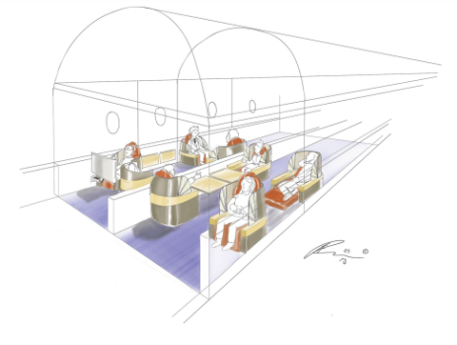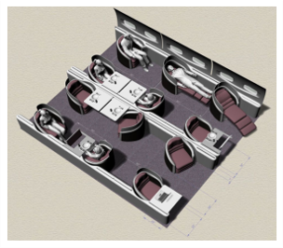

FIGURE 3.14 – Cabin sketch made with Adobe FIGURE 3.15 – Cabin 3D model made with Photoshop (MOERLAND-MASIC *et al.*, 2021). Rhyno (MOERLAND-MASIC *et al.*, 2021).

The Figures 3.16 and 3.17 show the same representation but made in a VR environment. The sketch was made inside the aircraft cabin and this could have been done with a client or a stakeholder and they could also draw and give their opinions from the beginning. The 3D models can be imported to increase the sketch’s level of detail.

This case was well received by the design team and they chosen to continue to use the VR tool. The benefits disadvantages pointed by MOERLAND-MASIC *et al.* are listed in the Table 3.3. The VR definitely helps to brings the clients closer to the design team, allows to draw quick sketches in brainstorming gatherings and has a steep learning curve for the designers. On the other hand, is its a high cost tool, the use during a long time can cause nausea and maybe other health implications and, even though the learning curve is steep, there is still a learning curve and the user needs to get used with the exposure to others that can see the user from outside the virtual environment (some find this situation uncomfortable).

The current master’s thesis isn’t about designing or aicraft cabin’s, but this research shows that VR is being studied to be implemented inside industries. The current research

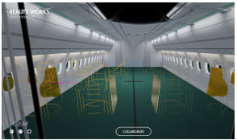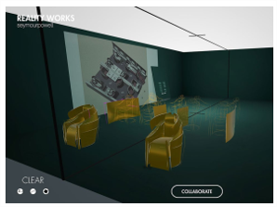

FIGURE 3.17 – VR navigation with imported FIGURE 3.16 – VR navigation with sketching

3D models (MOERLAND-MASIC *et al.*, 2021). (MOERLAND-MASIC *et al.*, 2021).

TABLE 3.3 – The benefits and disadvantages noted by the authors MOERLAND-MASIC *et al.*.

|  |  |
| --- | --- |
| Benefits | Disadvantages |
| Bottleneck at early concept design stages | High cost |
| Quick sketchs during brainstorming | Nausea and other health implacations |
| Steep learning curve | There is a learning and personal adaptation to exposure |

could be done by any product industry that wanted to create a test environment for their clients in order to increase the user’s approval or to bring other teams close to reduce the full design time.

# 4 Proposal description

This chapter is about the proposed methodology of this master thesis experiments. The Figure 4.1 shows the phases and the tasks inside each phase. This chapter will explain each phase and task presented in the Figure 4.1.

Interview’s

phase

Interview

withhospitals

Interview

withBVI

consultants

Scope’sphase

Virtual

environment

definition

Assessed

humanfactors

definition

Guidance

methods

definition

Development’s

phase

Virtualscenes

creation

Toolsand

methods

definition

Guidance

methods

development

Tryout’s

phase

Tryouts

Experiment’s

phase

Experiments

FIGURE 4.1 – Methodology’s diagram

## 4.1 Interviews’ phase

The first phase of this project was the Interviews’ phase. In these phase, the researchers’ main goal was to gather information, especially those related to the COVID-19 pandemic, about the main procedures that happen inside a hospital and about the daily life of BVI people.

### 4.1.1 Interview with the hospital

To understand the procedures that hospital and medical clinics followed during their day to day activities and during the COVID-19 pandemic, two hospitals were interviewed.

The interview was aimed to find out how a new patient does a check-in and the following steps until he/she get in the proper medic’s office.

At the project start, the scenario was supposed to be a reception inside a hospital, but, because of the physical space needed to simulate that virtual environment, the scenario changed along the project several times.

### 4.1.2 Interview with the BVI consultants

One of the motivations of this master thesis is that the current BVI guidance products are not effective enough and one of the likely reasons is that the BVI users were not consulted during the products development process.

With that though in mind, BVI users were consulted in order to design a virtual environment that would be familiar to their reality. Two users with different visual impairments were interviewed, one person that became blind with 13 years old, and other that with Usher’s disease. These were critical to understand how they perceive a medical clinic as they walk in and how they interact with the environment and these notes were used in the next phase.

## 4.2 Experiment idealization’s phase

At this phase, the proceedings and the interview notes are used to take key decisions about the virtual environment used in the experiment, about which human factors are going to be assessed and which guidance methods are going to be used

### 4.2.1 Experiment’s virtual world definition

As said before, the original idea was to use a hospital reception as model to the virtual environment for the experiment, however the physical space needed to fit the hospital was to big. So instead of a whole hospital reception, it was decided to use it a medical clinic reception but still with the same proceedings.

### 4.2.2 Assessed human factors definition

In order to reach the experiment’s objective, a set of human factors had to be choose. The objectives 2 and 3 could be reach if the assessed human factor represented the user’s workload and the developed mental map. Both these could be evaluated using:

* Mental workload
* Situation awareness

The details about each method are explained in the sections 2.2 and 2.3.

### 4.2.3 Guidance methods definition

The variety of BVI users is wide, as is the variety of assistive products. All of these products must communicate with the users and they use sound, vibration or both to transmit these information. With this though in mind, it was decided that that would be used at least two methods: one that rely only in audio and another that transmits only vibration. Of course, the interaction between those two methods would be also evaluated. This interaction became the third method.

Another interesting property that could be evaluated in those products is the effect of a information being transmitted with and without the user’s command. This evaluation split the vibration method in two: one that worked *without* the user’s command and another the worked *with* the user’s command.

At the end, the following methods were chosen to be analysed:

* A usual guidance method;
* Audio guidance;
* Vibration guidance without command;
* Vibration guidance with command;
* Mixture of audio and vibration.

## 4.3 Development and creation’s phase

With the decision of the previous phase it is possible to start the development of the virtual environment, the guidance methods and the tools for the assessment of the human factors.

### 4.3.1 Virtual world creation

The virtual reality application was made using the software Unity3D, which is a famous tool for virtual reality applications and game development. It has some built-in tools but is also possible to customize functions for more specific use (WANG *et al.*, 2010). The virtual environments, or scenes (as it is called inside the Unity3D), were made with the dimensions to fit in the CCM entry hall, that has a flat area of 8x4m. Inside the environment there was some typical furniture or devices found in hospital reception, a reception desk and a waiting area, composed of 2-3 chairs. The participant had 4 tasks at the scene and they are displayed at Figure 4.2. More details ahead at Chapter 5.

1. Clean the hands at the sanitizer totem (COVID-19 procedures);
2. Go to the reception desk to receive a queue number;
3. Go to the waiting area and wait for the number calling;
4. Leave the room when called

Sanitizertotem

Reception



Waitingarea

### Exit Entry

FIGURE 4.2 – Scheduled task of the experiment and their order.

The goal of these tasks is to engage the user to navigate through the room and see if it is able to draw a mental map of the scene as well as use the information of the obstacles in order to avoid them when needed. Beside theses mains components, there are also some minor distractions that is common to hear at a clinical, such as telephone ringing, keyboard typing, people taking and others. These were put to increase the immersion and to be a distraction as well, otherwise it wouldn’t simulate the reality of these scenarios.

#### 4.3.2 Tools and methods definition

There were three types of human factors’ assessment tools that were applied at the experiment:

• Task performance;

Measured using the time and the number contacts between the user and the furniture throughout the experiment. • Physiological measures;

Measured using and ECG sensor, a GSR sensor and a temperature sensor. • Subjective measures.

Measured using a NASA-TLX, a SAGAT Adapted questionnaire and a guidance method evaluation questionnaire.

The details about each method are explained in the sections 2.2.1, 2.2.2 and 2.2.3.

#### 4.3.3 Guidance methods development

As said in the last section, three different guidance methods were established to be used in the experiment besides the White Cane:, a haptic belt and a virtual cane.

* A audio guidance method;

The audio only guidance method will be straight simple. In the course of the experiment the participant could give two different voice commands:

* + ”What is around me?”;

The answer of this command was a quickly description of the closest furniture around the user.

* + ”Where is (something)?”.

The answer of this command was the direction and distance of something asked by the user.

Each command was answered by a member of the experiment team accordingly. • The haptic belt;

That is a belt that had appended 8 vibration devices that vibrate accordingly to the direction and distance of the closest object around the user. More information on the Haptic Belt ahead at Chapter 6.

* The virtual cane.

This was based on the white cane mechanics, that the user ”points”the cane to check near obstacles in the direction of the cane. The virtual cane has a similar function, but instead of connecting the user to the object through the cane, it vibrates when it detects an obstacle in the direction pointed by the user. A VR hand-control was used as canes and the user point’s it to where he/she wanted. The algorithm used on the Virtual Cane is in the Appendix B

## 4.4 Tryouts and tests’ phase

At this phase a few tests were performed to evaluate if the experiment was going as planned and to avoid any unfortunate events or errors during the real experiment. It was expected that changes could be needed to be made before the real experiment and there were a few. It was at this phase that the final dimension of the virtual environment and the physical space were defined.

## 4.5 Experiment

As the proper section name says, this phase is were the proper experiment was made.

After all these phases were completed, the next step was to analyze all the data and elaborate their conclusions. Instead of going to the results and discussions, the next Chapters 5 and 6 will deepen in the virtual environment development and in the haptic belt development in these order. The Figure 4.3 show a comparisson between the virtual environment created in Unity3D and the real environment assembled in the CCM’s entry hall.

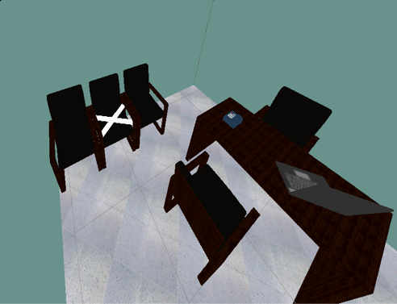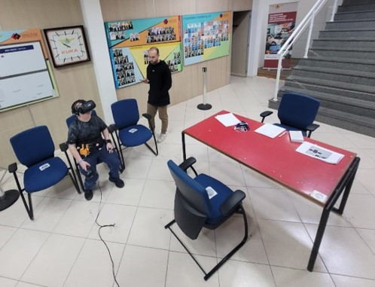

(a) Virtual environment screenshot (b) Real environment photo

FIGURE 4.3 – Environment comparisson

# 5 Virtual environment development

The main background and the source of the sensorial input was the virtual environment. Its development can be divided in 5 steps. The hole procedure is represented in the Figure 5.1.

1. Procedures
2. City Hospital
3. Medical Clinic
4. Adjustments
5. Final clinic

## 5.1 Procedures

The first step of the research was to learn how hospitals operate, especially throughout the COVID-19 pandemic. Two hospitals from the city of S˜ao Jos´e dos Campos - S˜ao Paulo were interviewed on how does the reception procedure worked and both of them had a similar operation:

1. Patient enters the hospital
2. Uses the sanitizer to clean their hands
3. Take a queue number and wait the calling of the receptionist
4. Go to the receptionist and does his/her check-in
5. Sits on the waiting area and wait until it’s name is called

Hospital

procedures

Cityhospital

1

stidea

Medical

ClinicV1

Toobig

Chairs

anddesk

Telephone

ringing

Keyboard

typing

1

stpresentation

TV

playing

People

chatting

Queue

machine

Medical

ClinicV2

Medical

ClinicV3

Medical

ClinicV4

Auditoriumcomplexity

Exterior

sounds

1

sttest

Medical

ClinicV5

FIGURE 5.1 – Virtual environment development process

The tasks in the experiment were to be similar as these procedures. The only exception was the name calling, step 5, because of the complexity of create a routine inside the virtual environment that could call the participant’s name. One possible solution was to use an actor, but because of the COVID-19 procedures that limits the number of people inside a room, this solution was discarded.

Since the procedures was from hospitals, the first idea of a virtual environment was to build a virtual hospital reception.

## 5.2 City Hospital

If the virtual environment was a hospital reception, it would be possible to include a lot of artifacts that could increase the participant’s sense of presence, such as people walking and the sound of elevators, and that was very appealing.

One problem with that idea was the physical space needed to simulate that. It would be needed a closed quarters space with enough area to allow the participant to walk through the hole reception. The original space was approximately 15x20m and the laboratory, or the university, didn’t had somewhere like that.

So the solution for that was to shrink down the area to fit inside the laboratory, so it was decided not to simulate a hospital reception, but a medical clinic reception

## 5.3 Medical Clinic

The laboratory didn’t had a room that could fit a hospital reception, but it did had a plenty of space that could fit a medical clinic reception, especially at the laboratory’s auditorium. The laboratory has 7x10m and that was the dimension of the first version of the virtual medical clinic. At the first moment, it was decided that this would be the setting for the experiment and its development went towards the definition of the interior details (blue path on the Figure 5.1), but other problems appeared along the development that the room dimensions needed to be redefined (red path on the Figure 5.1). Both of these modification are going to be detailed in the following Interior and Exterior subsections.

### 5.3.1 Interior

The goal of the interior was to increase the presence feeling of the participant inside the virtual environment. The inspiration was on the typical objects and furniture that a patient notices when waiting in a reception. The first objects positioned inside the reception was the desk, chairs (both normal and some with ”X” in the seats to represent a COVID-19 procedure), a telephone and a laptop. The last two also emitted sounds to increase the feeling of presence and to point to the BVI participant where the reception desk was located. The telephone and the laptop had a C# script to play their sounds randomly.

This virtual environment was presented to two BVI members of the research team and they pointed that it needed to have more noise, in order to increase even more the feeling of presence. They felt the lack of people chattering and the noise that came from a TV show, both were included in the virtual environment. To simulate the people chattering, dialogues from video or series between two people were used. The TV noise was made in a similar way, but with audio from famous Brazilian tv programs. Another missing artifact noticed by the team was the queue machine that was also included. All these added object also had a script that played a specific dialoque/program/queue order for each created scene, never repeating once, to increase the sensation of a different day [1].

After all of these objects were included, the interior was ready for a trial.

### 5.3.2 Exterior

The first version of the clinic had 7x10m, that was the exact dimension of the *Audit´orio Romi*, the room that was selected to be the physical space for the experiment. Since it was the exact dimension, it became the first change, since an extra space is needed to place the two VR Stations, that in the experiment was assembled in tripod basis. That modification became the second version of the clinic, with 5x7m.

The second modification came from the maximum distance between the VR Stations. Accordingly with ”SteamVR” (the software that was the interface between the computer and the VR) the maximum distance was 5m, besides that it could not guarantee the correct operation of the device. Besides that, the auditorium was filled with chairs and without a computer. Every time an experiment was going to be realized, it would be needed to rearrange the entire room, costing almost half a hour to clear the space and another half a hour to return to their place. The solution was to reduce, once more, the virtual environment dimensions to 4x4 and that was the third version of the medical clinic.

The forth version was reached because, even though smaller, the rearrangement of the auditorium was still a nuisance. The answer to that was to do the experiment in the entry hall. This was a empty space, just in front of the room where the computer with all the files was stationed. The only problem was that people passed by until 17h, but since the chosen of auditorium to be the physical space, it was scheduled that the experiment was going to be performed only at non-working hours.

With these Exterior and Interior modification, the environment was ready to receive

its first BVI participant.

## 5.4 Adjustments

The first BVI participant was the blind member of the research team and he enjoyed the final result, but still found a thing that could help to increase the feeling of presence. He pointed that BVI people normally find the exit of a room by searching the following sounds in sequence and repeatedly:

1. Sound of a door opening;
2. Noise from a exterior space (like people walking, cars passing by, horns, etc.);
3. Sound of a door closing.

After that note, a sound emitting point was added in each environment. This point played this sequence of sounds, but in a random interval.

5.5 Final Clinic

After that last addition, the clinic reached its final version.

# 6 Haptic belt development

Since haptic is one of the type of information that a BVI user can rely on, it was a good idea to test haptic devices in the experiment. This haptic devices would not detect the real object per se, but would receive the information from Unity3D based on the positon of the user inside the virutal environment.

The virtual cane was a simple development, since the controller already had a vibration motor inside of it. Knowing that, was only a matter to find the right commands and write a algorithm that worked. A pseudo-code is presented at Appendix B. The two differences between the virtual cane and the haptic belt are the command to check distance and the fact the with the cane the user must point to the direction where he/she wants to investigate if there is an obstacle whilst the belt indicates to the user the direction of the closest object.

The idea to design a haptic belt came as a suggestion from one of the research members. It was possible to buy one directly from the internet but the cost was too high, so it was decided to assemble one from scratch. The project was based on a haptic compass (KYLECORRY31, 2020), but instead of have the input being made by a magnetometer, it was made by the Unity3D.

The first prototype was made using a Arduino Mega 2560, LEDs and a protoboard. If Unity3D could send a command to turn the LED on, then the software would be able to do the same with a coin vibrator. After checking the communication between Unity3D and Arduino, it was time to build the proper belt.

The materials used were:

* DOIT ESP32 DevKit v1. (Datasheet in the Annex A);
* A printed circuit board (PCB)
* A leather belt;
* 8 Coin Vibrator 1027;
* 16 female P2 jacks or PJ-320B;

CHAPTER 6. HAPTIC BELT DEVELOPMENT 65

* 16 P2 male or PJ cable connectors;
* 8 straps;
* Duct tape;
* A 3D printed case.

The first step was to correct adapt the algorithm used on the Arduino to be used on ESP32 also using the LEDs. After it was made sure that it would also work with a ESP32, the system was designed in the EasyEDA website (EASY..., ) them a PCB was order with the schematic presented in the Appendix C. While the PCB didn’t arrive the coin vibrator and the cables were being soldered. When the PCB arrived, it was time to solder the board P2 jacks and design a case for it, represented in the Figure 6.1. After everything was soldered, printed, connected it was ready, as is represented in the Figure

6.2.

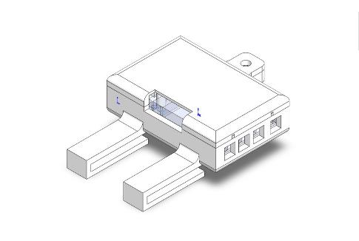

FIGURE 6.1 – CAD model of the designed case

Until these moment the belt was working cabled, but since the participant could walk great distances it was decided that the correct way to connect Unity3D with the ESP32 would be by wireless and it was decided to use a Bluetooth connection. The pseudo-code used in the development are in the Appendix C.

*Draft Version: May 31, 2022*

CHAPTER 6. HAPTIC BELT DEVELOPMENT

FIGURE 6.2 – Haptic belt

# 7

1. During one of the experiments, a BVI participant commented that he/she felt different day times for each time he/she did the scene